BIOLOGY SL - TOPICS 1 PART 1 MULTIPLE CHOICE
1.
2.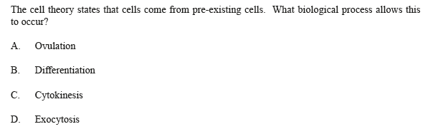
3.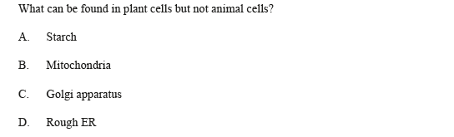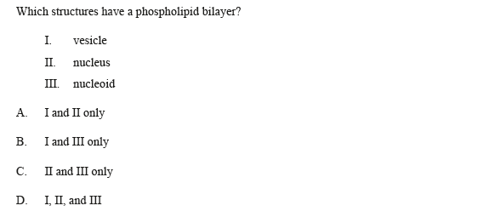
4.
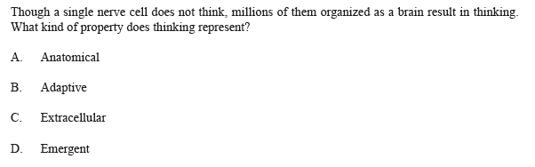
5.
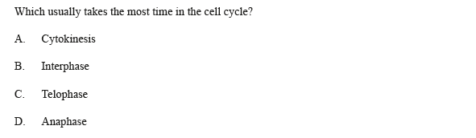
6.
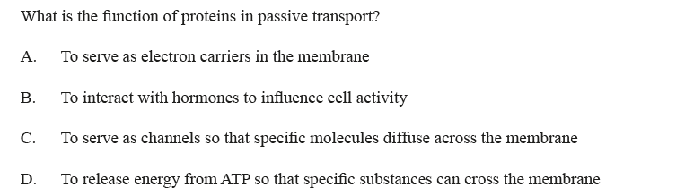

7.
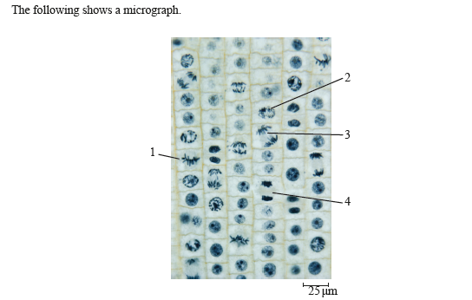
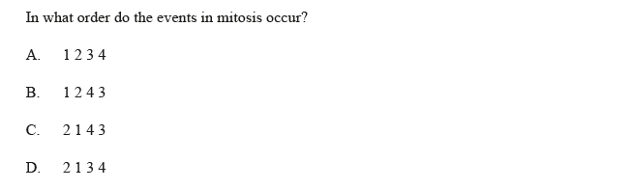

8.
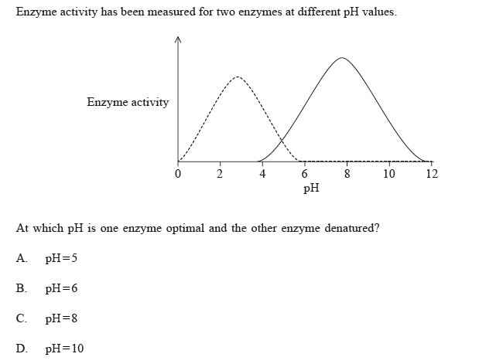
9.
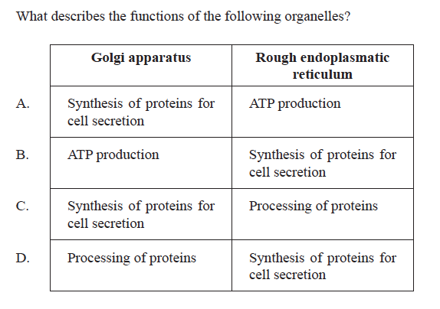

10.
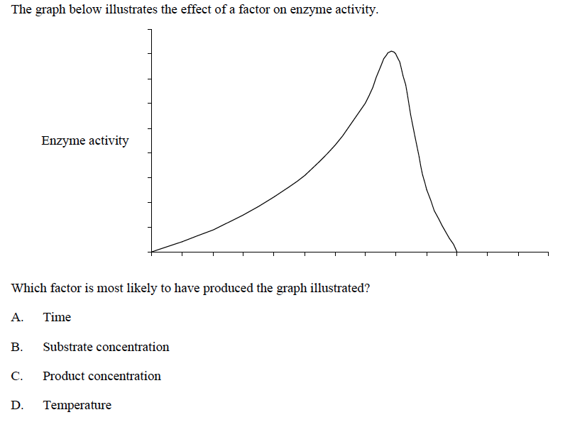

11.
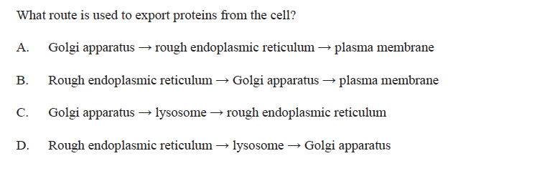

12. In a cell, what is the effect of a large surface area to volume ratio?

A. Slower rate of exchange of waste materials
B. Faster heat loss
C. Faster rate of mitosis
D. Slower intake of food

PART 2 (TAKEN FROM PAPER 2)

Question 1
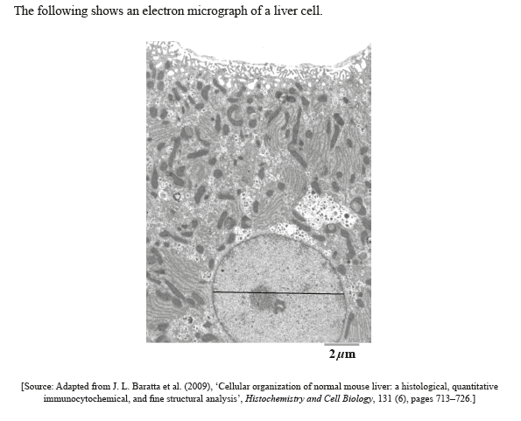
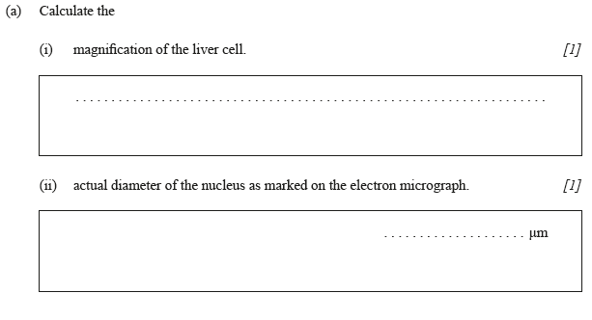
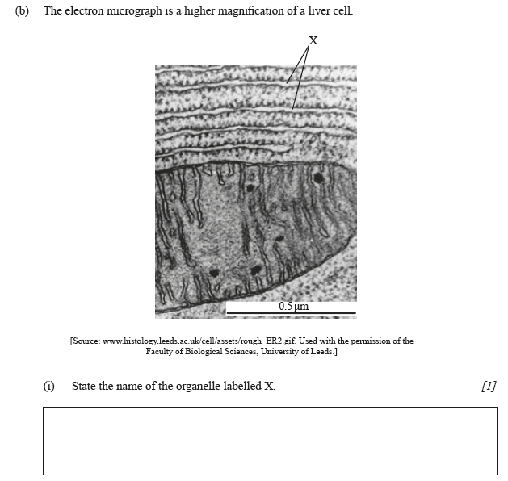
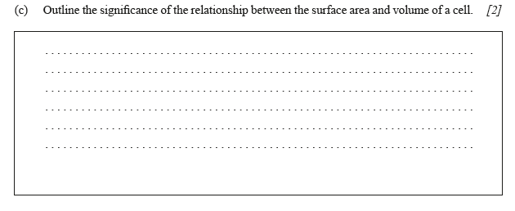
Question 2
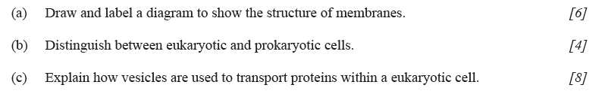
Question 3

Answers Part 1
- C  - A  - A  - D  - B  - C | - D  - C  - D  - D  - B  - B

Part 2
Question 1
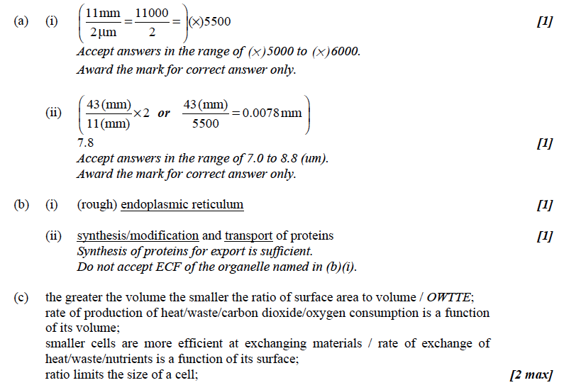

Question 2
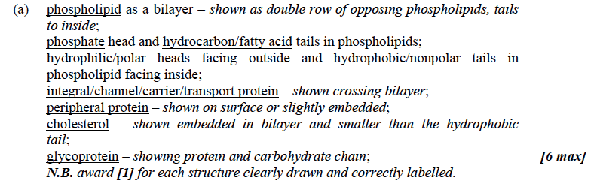
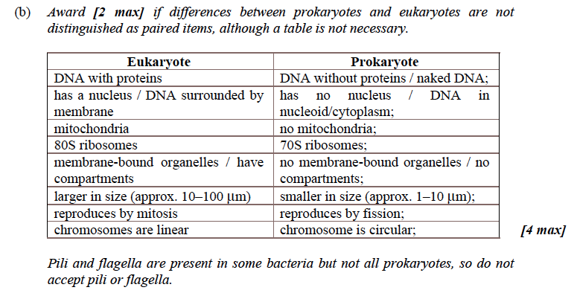
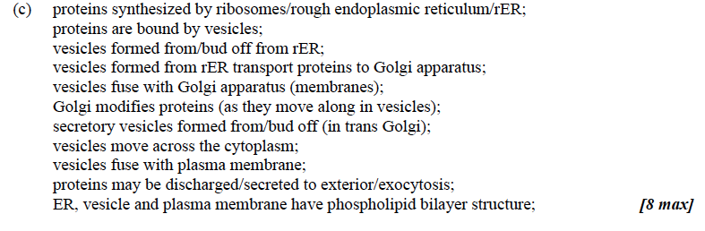
Question 3.
