Environmental Value Systems Definitions worksheet

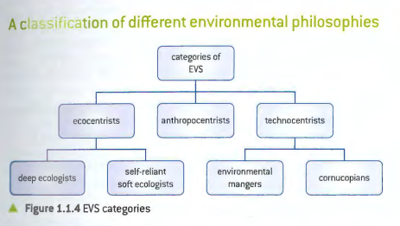

Value System Term | Definition | Example
Ecocentric
Deep Ecologists
Self-Reliant
Soft Ecologists
Biocentric
Anthropocentric
Technocentric
Environmental Managers
Cornucopians

