The Nitrogen Cycle:

1) Why is nitrogen important?

Nitrogen is an element in all living things. It is present in a variety of organic molecules, such as amino acids and, therefore, proteins. It is also present in the bases that make up DNA and RNA, so it is essential for the genetic structure of all life on earth. Because nitrogen is so important for life, if nitrogen is deficient in the environment it will severely limit biological productivity. Plants get the nitrogen they need by absorbing the solid forms of nitrogen, nitrate (NO₃) and/or ammonium (NH₄). Animals get the nitrogen they need by eating living or dead organic matter containing nitrogen. Nitrogen is also the largest constituent of the Earth’s atmosphere, comprising roughly 78% of the gases surrounding the planet.

2) Where is nitrogen present?

As seen in table 1, nitrogen is primarily stored in the mantle and core where it is largely unavailable to living things. Most of the nitrogen used by living things originally comes from the atmosphere. Once it’s captured from the atmosphere, it can be passed between living things until it finally makes its way back to the atmosphere or deep underground.

Table 1:
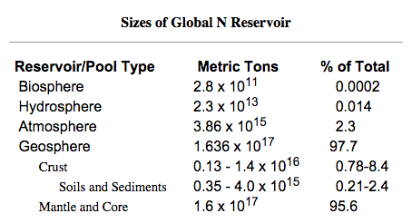

3) How does nitrogen get out of the atmosphere and into a form organisms can use? Answer: Nitrogen Fixation

In order for plants and other organisms to use nitrogen, it must first be changed into a form that organisms can use. This change is called “nitrogen fixation.” Nitrogen Fixation is the conversion of atmospheric nitrogen (N₂) into reactive compounds such as ammonia (NH₃) and nitrate (NO₃). The breaking of the bonds between the nitrogen atoms requires a great deal of energy and this can happen in a variety of natural and anthropogenic (human) processes.

A) Abiotic fixation: Abiotic fixation occurs without the help of living things. It is the result of high energy fixation in the atmosphere from lightning and cosmic radiation. In this process, N₂ is combined with oxygen to form nitrogen oxides such as NO and NO₂, which are carried to the earth’s surface in rainfall as nitric acid (HNO₃).

B) Anthropogenic fixation:
- Haber Process: Modern agriculture relies on man-made fertilizers to replace nitrogen lost from fields when farmers harvest their crops. These man-made nitrogen fertilizers are typically synthesized through the Haber process. The Haber process uses high temperatures and pressures to make ammonia from atmospheric nitrogen and a hydrogen source such as natural gas or petroleum.
- Burning Fossil Fuels: The burning of fossil fuels creates nitrogen oxides, such as NO and NO₂. As was the case with lightning, these combine with water and make nitric acid which falls to earth’s surface and eventually becomes available to plants .

C) Biological Fixation: Biological fixation is accomplished by a series of soil micro-organisms such as aerobic and anaerobic bacteria.
1) Symbiotic Fixation: Symbiosis is an interaction between two or more species that usually occurs over a long period of time, often to the benefit of both species. One example of symbiosis is the relationship between plants and bacteria living in the root nodules of those plants. Plants act as hosts for the bacteria, providing safety and some nutritional needs, while the bacteria fix nitrogen into ammonia, which the plants use as their nitrogen source. Rhizobium is a common bacteria that participates in this relationship and plants in the legume family (clover, beans, alfalfa, etc) are examples of plants that act as hosts for the bacteria.

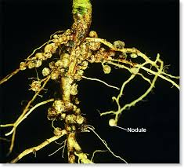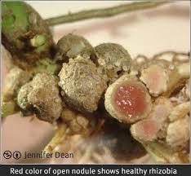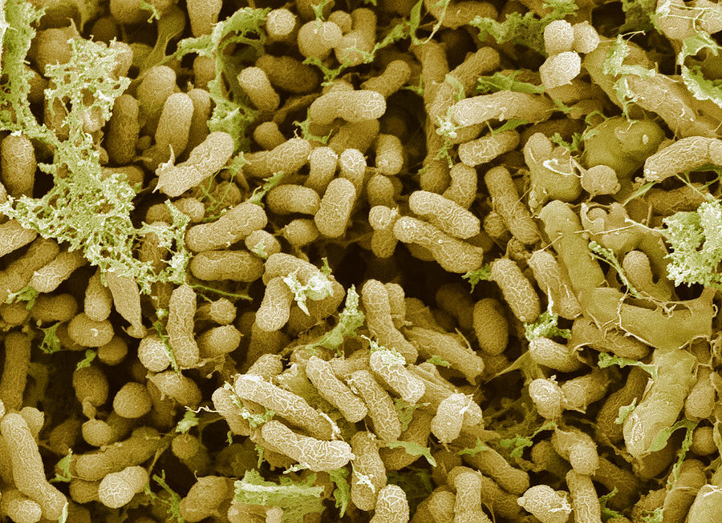
Figure 1: Root nodules Figure 2: Root nodules cut open Figure 3: Nitrogen Fixing bacteria

2) Non-symbiotic fixation: Some free-living aerobic bacteria, such as Azotobacter, and anaerobic bacteria, like Clostridium, freely fix nitrogen in the soil and in aquatic environments. Some members of the photosynthetic Cyanobacteria phylum fix nitrogen in aquatic environments as well.

Taken together, these forms of abiotic, anthropogenic, and biological fixation account for almost all of the nitrogen fixation on Earth. Figure 4 diagrams the relative sources of nitrogen fixation. It is easy to see from the diagram that humans are having a huge effect on the global nitrogen cycle.

Figure 4:
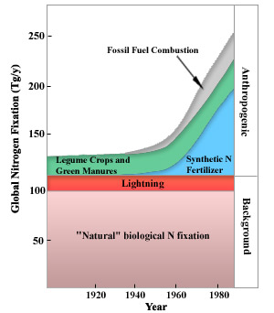

4) How does nitrogen transfer and transform once out of the atmosphere?

A) Nitrification: Nitrification is the process by which ammonia is oxidized to nitrite ions (NO₂) and then to nitrate ions (NO₃), which is the form most usable by plants. The two groups of microorganisms involved in the process are Nitrosomas and Nitrobacter. Nitrosomas oxidize ammonia to nitrite and Nitrobacter oxidize nitrite to nitrate (See Figure 5). The bacteria that carry out this reaction gain energy from it. Nitrification requires the presence of oxygen, so nitrification can happen only in oxygen-rich environments like circulating or flowing waters and the surface layers of soils and sediments.

Figure 5:

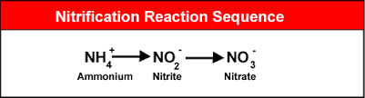

In Figure 6 below, you can see how ammonia introduced to an aquaponics system or other environment will cause a spike in ammonia. That spike, however, will disappear and reappear as a spike in nitrite as nitrosomonas bacteria oxidizes the ammonia into nitrite. The nitrite spike will then be replaced by a spike in nitrate as nitrobacter converts nitrite into nitrate.

Figure 6:

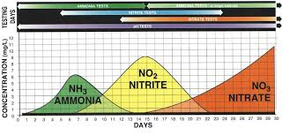

B) Assimilation: Nitrates are the form of nitrogen most commonly assimilated by plants through root hairs, but some plants use ammonia effectively. Since heterotrophic organisms cannot readily absorb nitrogen as plants do, they rely on acquiring nitrogen-based compounds through the food they eat. Since plants are the base of the food chain, the nitrogen-based compounds they have assimilated into their tissue will continue to pass from one organism to another (through consumption) as matter and energy transfers through the ecosystem’s food web. Once nitrogen is assimilated into an organism’s tissues, we say it is immobilized (immobilization), which is to say it is stuck in the tissues of that organism until it dies or is eaten by another organism. It is not free to be taken up by plant roots when it is immobilized.

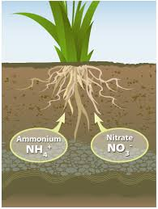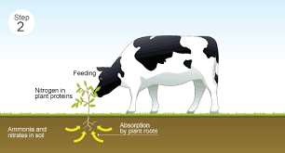
Figure 7: Plants assimilate Figure 8: Herbivores assimilate nitrogen Figure 9: Carnivores assimilate nitrogen through their root hairs by eating plants by eating animals

C) Ammonification/Decomposition: In ammonification, a host of decomposing microorganisms, such as bacteria and fungi, break down nitrogenous wastes and organic matter found in animal waste and dead plants and animals and convert it to inorganic ammonia (NH₃) for absorption by plants as ammonium ions. Therefore, decomposition rates affect the level of nutrients available to primary producers. When a nutrient becomes available for plants to use, it is said to be mineralized (mineralization).

5) How does nitrogen return to the atmosphere?

Denitrification: Denitrification is the process by which nitrates are reduced to gaseous nitrogen (N₂) and lost to the atmosphere. This process occurs by facultative anaerobes in anaerobic environments. Farmers with waterlogged fields and soils that have high clay content are especially vulnerable to nitrogen losses due to denitrification. Once again, this process is performed by bacteria. In this case, species such as Pseudomonas are involved.

Figure 10:
